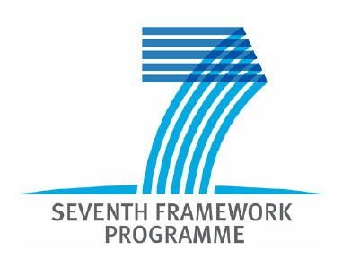
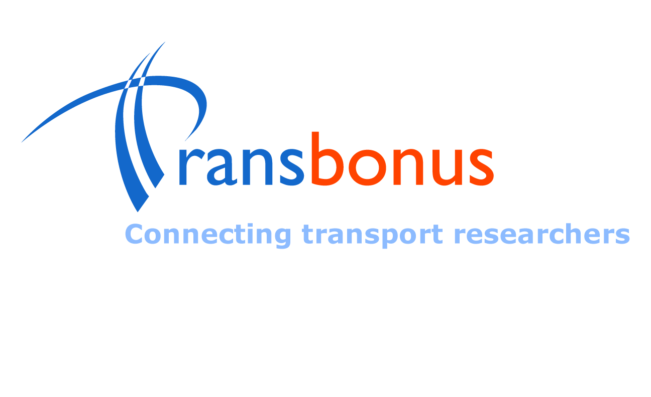

Welcome to the TransBonus Project

The aim of TransBonus project is to improve and promote closer Scientific and Technological (S&T) cooperation opportunities between Europe and the Western Balkan Countries (WBCs) in the area of Surface Transport. The project seeks to establish an EU-Balkan Transport network of researchers and universities among these countries in order to improve and/or enlarge the research capacity of Western Balkan centres of competence in transport in terms of improving their research programs, and scientific and technical human resources.

One of the objectives of TransBonus is to design and maintain R&D database for further RTD collaboration.
It is designed to:
- Identify research groups and individual researchers with specific competencies
- Help research groups and individual researchers to promote their competencies and initiate cooperation with other organisations
Who can register in the R&D database?
- Research groups (from Universities, Research company and Research center) from the surface transport domain from Bulgaria, FYR of Macedonia, Serbia, Bosnia and Herzegovina and Albania
- Individual researchers in the surface transport from these countries
Why register in TransBonus R&D database?
The registration will help us to promote your competencies. Other researchers will have the opportunity to use the database to contact you to:
- Participate in research projects
- Participate in national or European public tenders
- Participate in conferences, etc.
Filling in the questionnaire will take you around 30 minutes. When you complete the questionnaire, please send the document to the corresponding partner in your country (Albania, B&H, FYR of Macedonia, Bulgaria and Serbia) at: pikula@automotivecenter.ba

TECHNOLOGY PROFILE REGISTRATION FORM

A. Organisation’s Information Mandatory fields are marked with *
Company/organisation*:
Title:  Prof.  Dr  Ms  Mr.
First name*: | Name*:
Phone*: | E-mail*:
Address*: | Country*:

B. Technology Description (Technology Offer/ Request)
Title*: (Please describe your technology in one sentence)

Type of profile*:
Technology Profile |  Technology Offer  EU RTD Project / Result   Know-how/ expertise
Abstract / Description of the organisation*:

Description of the innovative aspects of the technology/ know how/ R&D result.
Please describe the innovative aspects of your research result or technology, presenting its main
advantages/special features*:
Innovative aspects of the technology*:

Main advantages of the technology offered/ special features of the technology requested*:

Key words describing the research result / technology*:

Current state of development of the technology* (Please select one item)
 Development phase – laboratory tested  Available for demonstration – field tested
 Already on the market  Other (please specify)

Intellectual Property Rights* (only for offers and EU RTD results)
 Patent(s) applied for but not yet granted
 Patent(s) granted by:
 European Patent Office
 National Patent Office
 Copyright protected
 Exclusive rights
 Secret know-how
 Others (registered design, plant variety right, etc.)*

Comments:

Web link to present innovative product:

C. Collaboration details

Type of collaboration sought* (more than one option can be selected)
 Further research or development support   Licence agreement   Technical co-operation   Joint Venture agreement   Other |  Commercial agreement with technical  assistance   Manufacturing/ subcontracting agreement   Financial resources   Other
Partners contribution sought for this research result/technology – Role and profile of the partners and
tasks to be performed (Mandatory) – Indicate clearly the*

- Type of partner sought* (such as: industry, academy, research organisation)

- The specific area of activity of the partner*

- The tasks to be performed of the partner sought*

