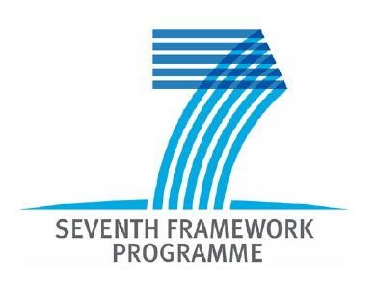
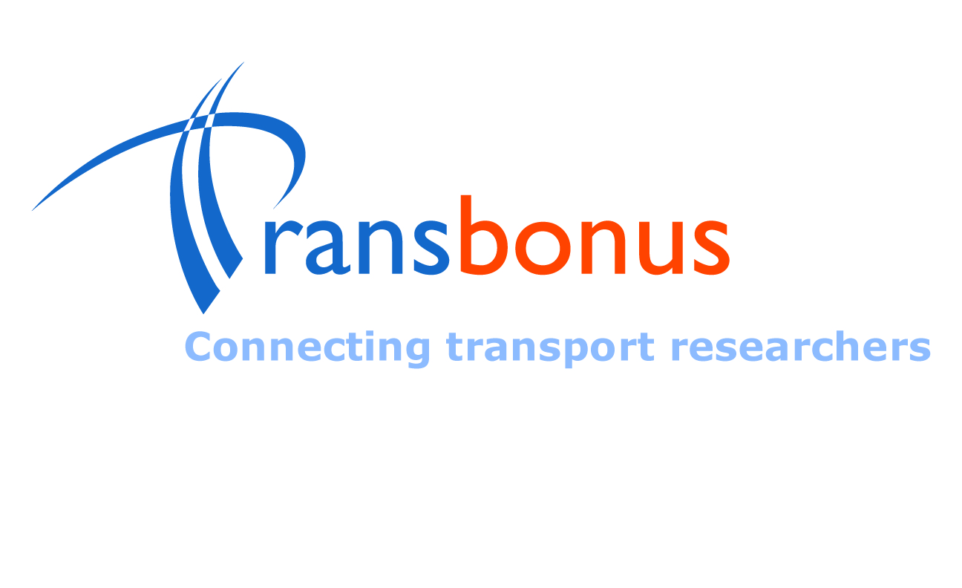

Welcome to the TransBonus Project

The aim of TransBonus project is to improve and promote closer Scientific and Technological (S&T) cooperation opportunities between Europe and the Western Balkan Countries (WBCs) in the area of Surface Transport. The project seeks to establish an EU-Balkan Transport network of researchers and universities among these countries in order to improve and/or enlarge the research capacity of Western Balkan centres of competence in transport in terms of improving their research programs, and scientific and technical human resources.

One of the objectives of TransBonus is to design and maintain a database with partners’ profiles interested in RTD collaboration within FP7. Thus, the TransBonus database will be populated with profiles of research groups (from universities, research center and research companies), researchers and intermediaries (research and business NGOs, government bodies) from the surface transport sector in the Western Balkan countries and Bulgaria.
It is designed to:
- Identify research groups and intermediaries with specific competencies
- Help research groups and intermediaries to promote their competencies and initiate cooperation with other organisations
Who can register in the database?
- Research groups and individual researchers from the surface transport domain from Bulgaria, FYR of Macedonia, Serbia, Bosnia and Herzegovina and Albania
- Intermediaries (from sectoral and business associations, branch chambers, NGOs) in the surface transport from these countries
- Policy makers (government bodies, regional/local authorities, certification bodies) in the surface transport from these countries
- Stakeholders in the surface transport from these countries
Why register in TransBonus database?
The registration will help us to promote your competencies. Other researchers will have the opportunity to use the database to contact you to:
- Participate in research projects
- Participate in national or European public tenders
- Participate in conferences
- Cooperate for a research co-publication, etc.
Filling in the questionnaire will take you around 15 minutes. When you complete the questionnaire, please send the document to the corresponding partner in your country (Albania, B&H, FYR of Macedonia, Bulgaria and Serbia) at: pikula@automotivecenter.ba

COLLABORATION PROFILE
1. Contact person details
First name: |  | Last name:
Phone: |  | E-mail:
2. Organisation details
Name:
Name of Department/ Institute/ Laboratory/ Unit:

If you are a large organisation (University, Research center, Large enterprise, etc.), please fill in the contact details of the specific department you are part of.
Address:
Please fill in the full address (Address, Postal code, City and Country).
Web site:
Type of organisation: (Please select your type of organisation in the surface transport sector.)
 Research organisation/ center  Stakeholder
 Secondary/ higher education establishment  Research company
 Researcher  Government body
 Non-governmental organisation – NGO  Regional/ Local authority
 Branch chamber  Certification body
 Business association
Number of employees in 2008 (including researchers): (Please select the number of employees.)
 <10  11-50  50-250  >250
Number of researchers in 2008:  0  <10  11-49  >50
Please select the number of researchers.
Research areas (Please select the research areas your organisation works):
 The greening of products and operations
 Clean and energy efficient gasoline and diesel power trains
 Electric-hybrid power trains
 Holistic noise and vibration abatement
 Future light-duty vehicle engines for road transport
 Future power-trains for commercial vehicles
 Emission reduction technologies for diesel locomotives
 Attenuation of vibration and vibration-induced noise affecting residents near railway lines
 New ship propulsion systems
 Green corridors
 Environment-friendly and efficient industrial processes
 Preventive and emergency interventions to protect marine, coastal and land environments
 Logistics and intermodal transport
 Efficient interfaces between transport modes
 Improved services in terminals
 New generation of European freight train system
 Continental Shipping
 Co-modal IT transport solutions
 Rail transport in competitive and co-modal freight logistics chains
 Maritime and inland waterways transport
 Enhancement of the knowledge base of the rail sector
 Quality of rail services
 Interoperability and safety
 Interoperable rolling stock
 Traffic and information management
 Intelligent highways
 New transport and mobility concepts
 New mobility concepts for passengers ensuring accessibility for all
 Intelligent mobility systems and multi-modal interfaces for transport of passengers
 New vehicle concepts for the delivery of goods
 Urban freight delivery systems
 Urban buses and delivery vehicles using second generation hybrid electric technology
 Transport planning and traffic information systems in cities
 Large event mobility management (especially in big cities)
 High quality public transport
 Demand management
 Innovative strategies for clean urban transport
 Integrated safety and security for surface transport systems
 Safety and security by design
 Human components
 Integral system solutions for safety
 Road Safety of Vulnerable Road Users in Emerging Economies
 Competitive industrial processes
 Advanced and cost effective infrastructure construction, maintenance and monitoring
 Competitive surface transport products and services
 Innovative product concepts
 Competitive transport operations
 The competitive ship
 Cross-cutting activities for implementation of the Surface Transport
 Policy of transport
 Other collaboration interests, please specify:

Description of organisation’s activities, products and services (max. 2.000 characters):

Topics of interest for future research collaboration in FP7 surface transport (Please select the topics of interest):
 The greening of products and operations
 Clean and energy efficient gasoline and diesel power trains
 Electric-hybrid power trains
 Holistic noise and vibration abatement
 Future light-duty vehicle engines for road transport
 Future power-trains for commercial vehicles
 Emission reduction technologies for diesel locomotives
 Attenuation of vibration and vibration-induced noise affecting residents near railway lines
 New ship propulsion systems
 Green corridors
 Environment-friendly and efficient industrial processes
 Preventive and emergency interventions to protect marine, coastal and land environments
 Logistics and intermodal transport
 Efficient interfaces between transport modes
 Improved services in terminals
 New generation of European freight train system
 Continental Shipping
 Co-modal IT transport solutions
 Rail transport in competitive and co-modal freight logistics chains
 Maritime and inland waterways transport
 Enhancement of the knowledge base of the rail sector
 Quality of rail services
 Interoperability and safety
 Interoperable rolling stock
 Traffic and information management
 Intelligent highways
 New transport and mobility concepts
 New mobility concepts for passengers ensuring accessibility for all
 Intelligent mobility systems and multi-modal interfaces for transport of passengers
 New vehicle concepts for the delivery of goods
 Urban freight delivery systems
 Urban buses and delivery vehicles using second generation hybrid electric technology
 Transport planning and traffic information systems in cities
 Large event mobility management (especially in big cities)
 High quality public transport
 Demand management
 Innovative strategies for clean urban transport
 Integrated safety and security for surface transport systems
 Safety and security by design
 Human components
 Integral system solutions for safety
 Road Safety of Vulnerable Road Users in Emerging Economies
 Competitive industrial processes
 Advanced and cost effective infrastructure construction, maintenance and monitoring
 Competitive surface transport products and services
 Innovative product concepts
 Competitive transport operations
 The competitive ship
 Cross-cutting activities for implementation of the Surface Transport
 Policy of transport
 Other topics of interest, please specify:

Main achievements (Please list your main research results, patents and patent applications, research reports and scientific articles):

Reference projects (Indicative list of research projects that your organisation has participated in the last 3 years both nationally and internationally):

What makes you a good research partner?:

